User’s Guide
Common Mapping and Transformation Service

Owner: caAdapter Development Team

Last Updated September 10, 2010

National Cancer Institute
Center for Biomedical Informatics and Information Technology
2115 East Jefferson Street
Rockville, MD 20852

 |   Center for Bioinformatics


Table of Contents

Table of Contents 2
ABOUT THIS GUIDE 5
Purpose 6
Audience 6
Organization of This Guide 6
Recommended Reading 7
Text Conventions Used 7
Credits and Resources 8
Chapter I Getting Started with caAdapter CMTS 8
About caAdapter CMTS 9
About XML Schema (XSD) 10
About XML Query 11
Prerequisites for Using caAdapter CMTS 11
Resources for Installing caAdapter CMTS 12
Starting caAdapter CMTS 12
Starting caAdapter CMTS from the Binary Distribution 12
Starting caAdapter CMTS from the Source Distribution 12
Starting caAdapter CMTS from the Windows Distribution 12
Starting caAdapter HL7 CMTS Online (WebStart) 12
caAdapter CMTS User Interface 12
File Menu 13
Help Menu 14
Chapter II Transformation Mapping 14
Transformation Mapping Rules 15
Understand Transformation Mapping 15
Overview of the Transformation Mapping Tab 15
Create New Transformation Mapping 16
Open existing transformation mapping 19
Create Mapping Link 20
Delete Mapping Link 22
Save Transformation Mapping 22
Use Functions in Transformation Mapping 22
Add function in transformation mapping 22
Create mapping from source schema entry to function input port 23
Create mapping from function input port to target schema entry 23
Delete function from transformation mapping 23
Edit Constant Function 23
Use Math Function Group 24
Use Date Function Group 24
Use String Function Group 24
Annotate XML Schema 24
Add Clone Element 25
Remove Clone Element 25
Select Choice Child Element 26
De-select Choice Child Element 26
Enable Recursion 27
Disable Recursion 27
Chapter III Data Transformation 28
Chapter IV Programming APIs 28
Chapter V Transformation Webservice 28

CABIG® OPEN SOURCE SOFTWARE
LICENSE
caAdapter 4.0, caAdapter 4.1 MMS, caAdapter 4.2 GME, caAdapter 4.3 HL7 MTS, caAdapter CMTS
Copyright Notice. Copyright 2007-2010 Science Applications International Corporation
(SAIC) (“caBIG™ Participant”). caAdapter was created with NCI funding and is part of
the caBIG® initiative. The software subject to this notice and license includes both
human readable source code form and machine readable, binary, object code form (the
“caBIG® Software”).
This caBIG® Software License (the “License”) is between caBIG® Participant and You.
“You (or “Your”) shall mean a person or an entity, and all other entities that control, are
controlled by, or are under common control with the entity. “Control” for purposes of
this definition means (i) the direct or indirect power to cause the direction or
management of such entity, whether by contract or otherwise, or (ii) ownership of fifty
percent (50%) or more of the outstanding shares, or (iii) beneficial ownership of such
entity.
License. Provided that You agree to the conditions described below, caBIG®
Participant grants You a non-exclusive, worldwide, perpetual, fully-paid-up, no-charge,
irrevocable, transferable and royalty-free right and license in its rights in the caBIG™
Software, including any copyright or patent rights therein, to (i) use, install, disclose,
access, operate, execute, reproduce, copy, modify, translate, market, publicly display,
publicly perform, and prepare derivative works of the caBIG® Software in any manner
and for any purpose, and to have or permit others to do so; (ii) make, have made, use,
practice, sell, and offer for sale, import, and/or otherwise dispose of caBIG® Software
(or portions thereof); (iii) distribute and have distributed to and by third parties the
caBIG® Software and any modifications and derivative works thereof; and (iv)
sublicense the foregoing rights set out in (i), (ii) and (iii) to third parties, including the
right to license such rights to further third parties. For sake of clarity, and not by way of
limitation, caBIG® Participant shall have no right of accounting or right of payment from
You or Your sublicensees for the rights granted under this License. This License is
granted at no charge to You. Your downloading, copying, modifying, displaying,
distributing or use of caBIG® Software constitutes acceptance of all of the terms and
conditions of this Agreement. If you do not agree to such terms and conditions, you
have no right to download, copy, modify, display, distribute or use the caBIG™
Software.
1. Your redistributions of the source code for the caBIG® Software must retain the
above copyright notice, this list of conditions and the disclaimer and limitation of
liability of Article 6 below. Your redistributions in object code form must
reproduce the above copyright notice, this list of conditions and the disclaimer
of Article 6 in the documentation and/or other materials provided with the
distribution, if any.
2. Your end-user documentation included with the redistribution, if any, must
include the following acknowledgment: “This product includes software
developed by Science Applications International Corporation (SAIC).” If You do
not include such end-user documentation, You shall include this
acknowledgment in the caBIG® Software itself, wherever such third-party
acknowledgments normally appear.
3. You may not use the names “Science Applications International Corporation”,
"SAIC", “The National Cancer Institute”, “NCI”, “Cancer Bioinformatics Grid” or
“caBIG™” to endorse or promote products derived from this caBIG® Software.
This License does not authorize You to use any trademarks, service marks,
trade names, logos or product names of either caBIG® Participant, NCI or
caBIG®, except as required to comply with the terms of this License.
4. For sake of clarity, and not by way of limitation, You may incorporate this
caBIG® Software into Your proprietary programs and into any third party
proprietary programs. However, if You incorporate the caBIG® Software into
third party proprietary programs, You agree that You are solely responsible for
obtaining any permission from such third parties required to incorporate the
caBIG® Software into such third party proprietary programs and for informing
Your sublicensees, including without limitation Your end-users, of their
obligation to secure any required permissions from such third parties before
incorporating the caBIG® Software into such third party proprietary software
programs. In the event that You fail to obtain such permissions, You agree to
indemnify caBIG® Participant for any claims against caBIG® Participant by
such third parties, except to the extent prohibited by law, resulting from Your
failure to obtain such permissions.
5. For sake of clarity, and not by way of limitation, You may add Your own
copyright statement to Your modifications and to the derivative works, and You
may provide additional or different license terms and conditions in Your
sublicenses of modifications of the caBIG® Software, or any derivative works of
the caBIG® Software as a whole, provided Your use, reproduction, and
distribution of the Work otherwise complies with the conditions stated in this
License.
6. THIS caBIG® SOFTWARE IS PROVIDED "AS IS" AND ANY EXPRESSED OR
IMPLIED WARRANTIES (INCLUDING, BUT NOT LIMITED TO, THE IMPLIED
WARRANTIES OF MERCHANTABILITY, NON-INFRINGEMENT AND
FITNESS FOR A PARTICULAR PURPOSE) ARE DISCLAIMED. IN NO
EVENT SHALL SCIENCE APPLICATIONS INTERNATIONAL CORPORATION
(SAIC) OR ITS AFFILIATES BE LIABLE FOR ANY DIRECT, INDIRECT,
INCIDENTAL, SPECIAL, EXEMPLARY, OR CONSEQUENTIAL DAMAGES
(INCLUDING, BUT NOT LIMITED TO, PROCUREMENT OF SUBSTITUTE
GOODS OR SERVICES; LOSS OF USE, DATA, OR PROFITS; OR BUSINESS
INTERRUPTION) HOWEVER CAUSED AND ON ANY THEORY OF LIABILITY,
WHETHER IN CONTRACT, STRICT LIABILITY, OR TORT (INCLUDING
NEGLIGENCE OR OTHERWISE) ARISING IN ANY WAY OUT OF THE USE
OF THIS caBIG® SOFTWARE, EVEN IF ADVISED OF THE POSSIBILITY OF SUCH DAMAGE.

ABOUT THIS GUIDE
This section introduces you to the caAdapter Common Mapping and Transformation Service (CMTS) User’s Guide.

Topics in this section:
- Purpose on this page
- Audience on this page
- Organization of This Guide on page 2
- Recommended Reading on page 3
- Text Conventions Used on page 3
- Credits and Resources on page 4

Purpose
This guide is the companion documentation to caAdapter Common Mapping and Transformation Service (caAdapter CMTS) module. It includes information and instructions for using both the caAdapter CMTS Application Programming Interfaces (APIs) and graphical user interface (GUI).

Audience
Typical User
This guide is designed for the following types of users:
- Technical users (such as Java programmers and system architects) who want to use the major CMTS APIs to parse, build, and validate XML data/messages driven by schema (XSD); and
- Analysts (such as HL7 analysts, database administrators, and business analysts) who need step-by-step procedures for creating XML message instances using.

Prerequisites
This guide assumes that you are familiar with the W3C XML schema recommendation.

Use of CMTS module requires additional prerequisites. For more information, see Prerequisites for Using caAdapter CMTS on page xx.

Organization of This Guide
The caAdapter Common Mapping and Transformation Service(CMTS) User’s Guide includes the following chapters:

- Chapter 1, Getting Started with caAdapter CMTS, on page 5 discusses the caAdapter CMTS architecture and related data standards.
- Chapter 2, Using caAdapter CMTS, on page 15 provides a high-level overview of using caAdapter CMTS.
- Chapter 3, CSV to HL7 v3 Mapping and Transformation, on page 19 explains the procedures for using caAdapter HL7 MTS v4.3 to perform for CSV to HL7 v3 mapping and transformation.
- Chapter 4, Converting HL7 v2 to HL7 v3 Messages, on page 59 provides detailed instructions for using the caAdapter HL7 MTS v4.3 GUI for HL7 v2 to HL7 v3 conversion.
- Chapter 5, Using Functions in Mapping, on page 63 provides detailed instructions for using and adding functions in caAdapter HL7 MTS v4.3 mappings.
- Chapter 6, Using the caAdapter HL7 MTS v4.3 APIs, on page 69 provides Java developers information required to use caAdapter HL7 MTS v4.3 APIs.
- Chapter 7, caAdapter HL7 MTS v4.3 Web Services Transformation Module, on page 73 provides detailed instructions for using the caAdapter HL7 MTS v4.3 Web Service.
- Chapter 8, caAdapter HL7 MTS v4.3 File Types, on page 81 provides an overview of the different types of files used by caAdapter HL7 MTS v4.3 and an example of each.
- Appendix A, caAdapter HL7 MTS v4.3 Glossary, on page 93 defines acronyms, objects, tools and other terms related to caAdapter HL7 MTS v4.3.
- Appendix B, caAdapter HL7 MTS v4.3 Example Data, on page 95 provides a description of the example data delivered with caAdapter HL7 MTS v4.3.
- Appendix C, References, on page 97 provides a list of references used to produce this guide or referred to within the text.

Recommended Reading
The following table lists resources that can help you become more familiar with concepts discussed in this guide.
Resource | URL
W3C XML Schema Definition (XSD) | http://en.wikipedia.org/wiki/XML_Schema_(W3C)
XML Query (XQuery) | http://en.wikipedia.org/wiki/XQuery
XMP Path Language (XPath) | http://www.w3.org/TR/xpath/
Health Level 7 (HL7) | http://en.wikipedia.org/wiki/Health_Level_7
HL7 Version 2.x | http://en.wikipedia.org/wiki/Health_Level_7#HL7_Version_2.x
HL7 Version 3 | http://en.wikipedia.org/wiki/Health_Level_7#HL7_Version_3
ISO 21090 Data Types | http://www.kith.no/upload/4414/ISODIS21090.pdf
Unified Modeling Language (UML) | http://www.cdisc.org/models/sds/v3.1/
cancer Biomedical Informatics Grid (caBIG) | https://cabig.nci.nih.gov/

Click the hyperlinks throughout this guide to access more detail on a subject or product.

Text Conventions Used
This section explains conventions used in this guide. The various typefaces represent interface components, keyboard shortcuts, toolbar buttons, dialog box options, and text that you type.
Convention | Description | Example
Bold | Highlights names of option buttons, check  boxes, drop-down menus, menu  commands, command buttons, or icons. | Click Search.
URL | Indicates a Web address | http://domain.com
text in SMALL CAPS | Indicates a keyboard shortcut | Press ENTER
text in SMALL CAPS + text in SMALL CAPS | Indicates keys that are pressed simultaneously | Press SHIFT + CTRL
Italics | Highlights references to other documents, sections, figures, and tables | See Figure 4.5.
Italic boldface monospaced type | Represents text that you type | In the New Subset text box,enter  Proprietary Proteins
Note: | Highlights information of particular importance | Note: This concept  is used throughout  the document.
{ } | Surrounds replaceable items | Replace {last name, first name} with the Principal Investigator’s name
caAdapter HL7 Mapping and Transformation Service Version 4.3 User’s Guide

Credits and Resources
The following people contributed to the development of this document.
caAdapter Common Mapping and Transformation Service Development and Management Teams
Development |  | Documentation | Program Management
Eugene Wang2 |  | Carolyn Kelley Klinger4 | Sichen Liu1
Ki Sung Um2 |  |  | Anand Basu1
Ye Wu2 |  |  | Avinash Shanbhag1
 |  |  | Sudha Chudamani4
 |  |  | Sharon Gaheen2
1 Center for Biomedical Informatics and Information Technology (CBIIT)
2 Science Application International Corporation(SAIC)
3 SAIC-Frederic, Inc
4 Lockheed Martin Management System Designers
Contacts and Support
Application Support | http://ncicb.nci.nih.gov/NCICB/support  Telephone: 301-451-4384  Toll free: 888-478-4423
LISTSERV Facilities Pertinent to caAdapter Common Mapping and Transformation Service
LISTSERV | URL |  |  | Name
caAdapter_Users | https://list.nih.gov/archives/caadapter_users-l.html |  |  | caAdapter CMTS Users Discussion Forum

Chapter I Getting Started with caAdapter CMTS
This chapter provides an overview of caAdapter Common Mapping and Transformation Service (CMTS) module, its architecture, and its related data standards.

Topics in this chapter include:
- About caAdapter CMTS on page xx
- About XML Schema (XSD) on page xx
- About XQuery on page xx
- Prerequisites for caAdapter CMTS on page xx
- Resources for caAdapter CMTS on page xx
- Starting caAdapter CMTS on page xx
- caAdapter CMTS User Interface on page xx

About caAdapter CMTS
The National Cancer Institute Center for Biomedical Informatics and Information Technology (NCI CBIIT) developed the caAdapter tool with the goal of creating standards-based infrastructure components to facilitate medical research data exchange. caAdapter is a open source tool kits including Module Mapping Service, HL7 Map and Transformation Service, Global Model Exchange Service, and Common Mapping and Transformation Service (CMTS). The module facilitates data mapping and transformation among different kinds of data sources including CSV, XML, HL7 v2 messages, HL7 v3 messages, and Study Data Tabulation Model (SDTM) data sets.

CMTS module is enabled with ISO 21090 standard which is jointly balloted between the International Organization for Standardization (ISO) and the Health Level Seven (HL7). ISO 21090 standards provides set of data type definitions for representing and exchanging basic concepts that are commonly encountered in healthcare environments in support of information exchange in the healthcare environment and specifies a collection of healthcare related data types suitable for us in a number of health related information environments. The semantics of these data types are declared with the terminology, notations and data types (referred to as the Language-Independent (LI) Data types) specified in ISO 11404 rev. 2005. The standard also provides UML definitions of the same data types using the terminology, notation and types defined in Unified Modeling Language (UML) version 2.0. XML definitions of the same data types are described with XML schema (XSD) derived from the UML representation of the specification using XML encoding rules and mapping between UML primitive types and XML types. The XSD provides a normative XML format for use when instance of these data are represented in XML. It is suitable for use when exchanging information between information processing entities. The XSD validation is required whether an XML instance is conformant with the ISO 21090 specification.

CMTS will be developed on the basis of XML schema (XSD) specification. XSD file defines the structure, content and semantics of source data or target data. Mapping engine creates links between nodes of source XSD and target XSD. Transformation engine parses source data based source XSD, generates target data based target XSD using mapping data.

The primary objectives of the CMTS module are:
- Model and represent XSD as meta of generic XML, ISO 21090 enabled XML, CDA, CCD, CSV, HL7 v2, etc.
- Implement XML data parser conform with XSD
- Implement adaptors of data parser to support CSV, HL7 v2 as source data
- Produce XML instances conformed to XSD specification.
- Implement functionalities data manipulation functions
- Provide API for application and service integration

The objective of the architecture design is to leverage the state-of-art Java and XML technologies, and to organize in a highly modularized fashion that enables easy expansion that can adapt to any future needs. The architecture should also effectively streamline the main functional modules, so that it can achieve an overall high performance.
The architecture diagram is as following.
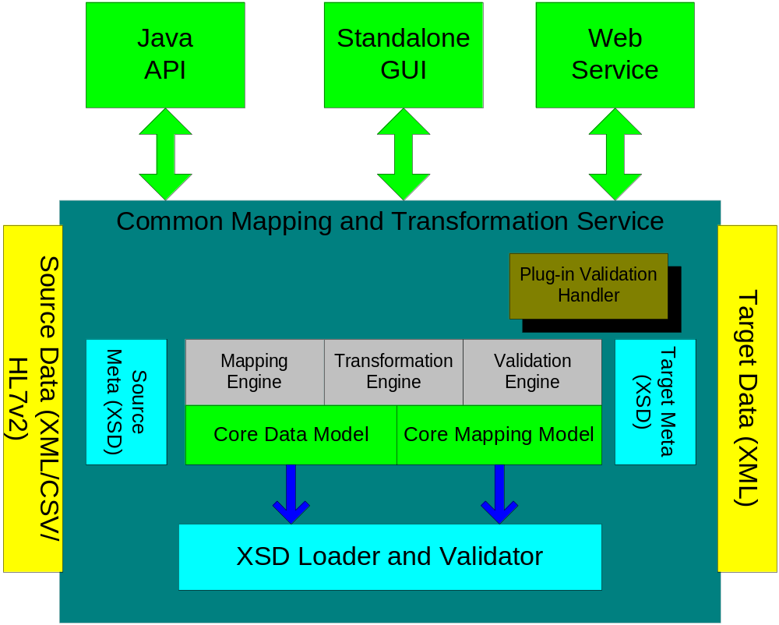
Figure 1 Architecture Diagram

About XML Schema (XSD)
An XML schema is a description of a type of XML document, typically expressed in terms of constraints on the structure and content of documents of that type, above and beyond the basic syntactical constraints imposed by XML itself. These constraints are generally expressed using some combination of grammatical rules governing the order of elements, Boolean predicates that the content must satisfy, data types governing the content of elements and attributes, and more specialized rules such as uniqueness and referential integrity constraints.
There are languages developed specifically to express XML schemas. The Document Type Definition (DTD) language, which is native to the XML specification, is a schema language that is of relatively limited capability, but that also has other uses in XML aside from the expression of schemas.
The W3C's XML Schema language, also known as XSD (XML Schema Definition), published as a W3C recommendation in May 2001, is one of several XML Schema language. It was the first separate schema language for XML to achieve Recommendation status by the W3C. Like all XML schema languages, XSD can be used to express a set of rules to which an XML document must conform in order to be considered 'valid' according to that schema. However, unlike most other schema languages, XSD was also designed with the intent that determination of a document's validity would produce a collection of information adhering to specific data types.

About XML Query
XQuery is a query language (with some programming language features) that is designed to query collections of XML data. It is semantically similar to SQL.
XQuery is standardized by W3C, the organization that maintains all XML related standards such as XML, XML Schema, SOAP, and WSDL. It also gains support from major software vendors such as Microsoft, IBM, Oracle, and SUN Microsystems from the very beginning of its standardization process.
XQuery provides the means to extract and manipulate data from XML documents or any data source that can be viewed as XML, such as relational databases or office documents.
XQuery is a programming language that can express arbitrary XML to XML data transformations with the following features:
- Logical/physical data independence
- Declarative
- High level
- Side-effect free
- Strongly typed language

Prerequisites for Using caAdapter CMTS
The following skills will ensure successful use of caAdapter CMTS:
- Thorough familiarity with XSD
- Understanding various data formats including CSV, HL7 v2 and HL7 v3
- Training on caAdapter CMTS
- Familiarity with caAdapter CMTS mapping rules

Resources for Installing caAdapter CMTS
Complete instructions for installing caAdapter CMTS are located in the
caAdapter CMTS Installation Guide at http://ncicb.nci.nih.gov/NCICB/infrastructure/cacore_overview/caadapter/.

Starting caAdapter CMTS

Starting caAdapter CMTS from the Binary Distribution
To start the caAdapter CMTS from binary distribution, follow these steps:
1. In a Command Prompt window, enter cd {CMTS home directory} to go to your home directory (Windows example: C:\cmts).
2. Enter run.bat. caAdapter CMTS appears.

Starting caAdapter CMTS from the Source Distribution
To start the caAdapter CMTS source distribution, follow these steps:
1. In a command prompt window, enter cd {home directory} to go to your caAdapter CMTS source directory (Windows example: C:\cmtsSrc).
2. Enter ant.
3. Enter cd dist.
4. Enter run.bat. caAdapter CMTS appears.

Starting caAdapter CMTS from the Windows Distribution
To start caAdapter CMTS from Microsoft Windows:
Select Start > caAdapter CMTS. caAdapter CMTS appears.

Starting caAdapter HL7 CMTS Online (WebStart)
You can also use caAdapter CMTS online without having to install the software by clicking the link in the Use caAdapter CMTS Online section on the following page:
http://ncicb.nci.nih.gov/NCICB/infrastructure/cacore_overview/caadapter.

Once you click the link, caAdapter CMTS will download to your server and launch, running locally. Your data will not be uploaded to a CBIIT server.

caAdapter CMTS User Interface
This section includes the following topics:
- File Menu on page xx
- Help Menu on page xx
- Tabs on page xx
The caAdapter CMTS interface is Windows-based and includes a main menu bar, a tool bar, and tabs located in the top of the window. You can resize the various panels by selecting the edge of the panel and dragging. Scroll bars appear when needed to display all of the information.
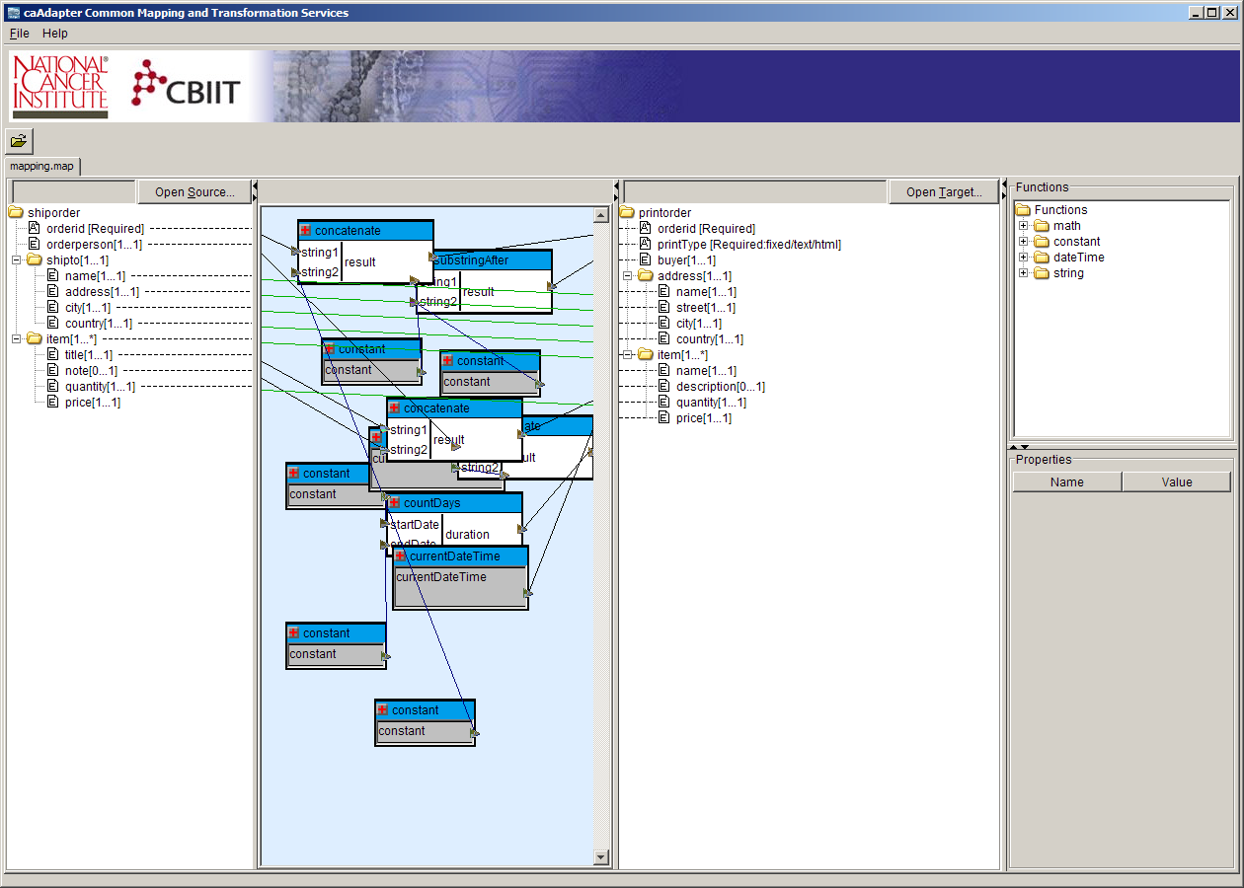
Figure 1.3 caAdapter CMTS Interface

File Menu
Select the File menu to perform the functions in Table 1.1.
File Menu Item | Description
New | Creates a new file for the type of file you select including:  - Transformation Mapping  - XML to XML Transformation  - CSV to XML Transformation  - HL7 v2 to XML transformation
Open | Opens an existing transformation mapping file(.map)
Save (CTRL + S) | Saves the file you are currently working on (in the selected tab).
Save as | Opens a Save As dialog box to allow you to save the file to another file name
Close (CTRL + F4) | Closes the file you are currently working on in the selected tab. The following message appears if you have not saved your work: Data hasbeen changed but is not saved. Would you like to save your changes?  Select Yes, No, or Cancel.
Close all | Closes all open files.
Exit (ALT + F4) | Close all open files and exit caAdapter CMTS application
Table 1.1 File menu command

Help Menu
Select the Help menu learn more about caAdapter HL7 MTS v4.3. The following table explains the menu options.
Help Menu Item | Description
About caAdapter CMTS | View a description of caAdapter CMTS and its license and copyright information.
Help – Contents and Index | Open a browser window that contains online help for CMTS. Tabs appear on the left of the browser window that allow you to search for help topics in a traditional table of contents as well as an index.
Table 1.2 Help menu commands

Tabs
caAdapter CMTS uses a document-oriented paradigm where up to four files of different types can be open at the same time, each within its own tab in a single window. The four different types of tabs are:
XML schema file (XSD)
XML data file (.xml)
CSV data file (.csv)
HL7 v2 message file (.hl7)

In some cases, such as with .map, only one of each file type may be open at a time. If you open a new file of a file type that is restricted and already open, then the existing file will be replaced with the new file. The tab name is either the name of the file in the tab or untitled.<ext>, where <ext> is the appropriate file extension for that type of tab. The window layout changes depending on the type of tab displayed. For example, the HL7 v3 specification tab displays a tree structure in the left-hand panel and the properties and validation messages in the right-hand panel.

Chapter II Transformation Mapping
A transformation mapping defines the relationship among source data schema, target schema and data manipulation functions. It also contains annotation information about the source data schema and target data schema.

caAdapter CMTS provides a link between one of the following:
- a source data schema entry to a target data schema entry
- a source data schema entry to a function’s input port
- a function’s output port to a target data schema entry

The annotation information includes:
- one and only one chosen child element of a choice group
- one or more cloned record(s) of an element

This section contains the following topics:
- Transformation mapping Rules on page xx
- Create Mappings on page xx
- Schema annotation on page xx
- Chapter III Data Transformation

Transformation Mapping Rules
The following are the rules for a transformation mapping:
- It must contain a valid mapping pair (source data schema and target data schema files).
- The source entry referenced must exist in the source data schema
- The destination entry referenced must exist in the target data schema
- A mandatory target element must have either a mapping from source or predefined default value in its schema
- Each input parameter for a function must have a mapping from source or a constant defined.
- Each output parameter for a function must have a mapping to target

Understand Transformation Mapping
This section includes the following topics:
- Overview of the Transformation Mapping Tab on page xx
- Create a New transformation Mapping on page xx
- Open an Existing transformation Mapping on page xx
- Create a Mapping Link on page xx
- Delete a Mapping Link on page xx
- Save Transformation Mapping on page xx
- Use Functions in Transformation Mapping on page xx
- Annotate Schema on page xx

Overview of the Transformation Mapping Tab
The transformation mapping tab graphically present user a transformation mapping with links, function box, schema annotation, etc. In the source panel and the target panel, the schema structure is visually represented using an expandable/collapsible tree structure. Both the source schema and the target schema must be valid XML schema (XSD). The transformation Mapping tab (Figure 3.2) consists of the following:

Two tree panels - contain the source specification in the left-hand panel and the target specification in the right-hand panel.
Center mapping panel - displays the lines that indicate the mapping between source and target elements and any functions that are used in the mappings.
Functions panel - displays a tree of available functions.
Properties panel - changes depending on the item selected in the other panels (for example, displays link properties, HL7 v3 specification data type field properties, CSV field properties, etc.).
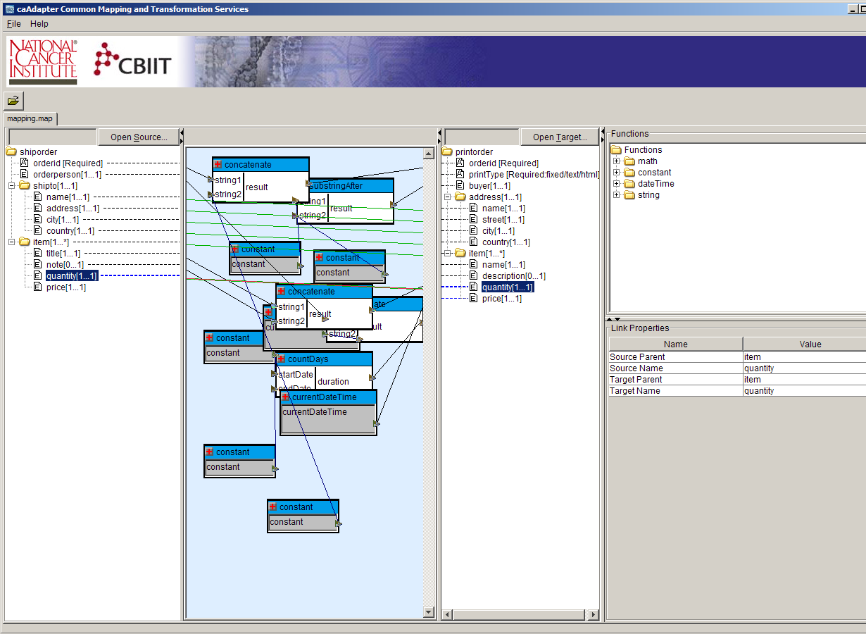
Figure 3.xx Transformation Mapping Tab

The tree structures are read-only; you must make any changes to the tree structures in the source or target schema files (.xsd). You can only define the mappings or perform annotation operation from this tab.

Caution: Adding to source or target specifications that are referenced in a map file is allowable, but editing or removing source or target elements may result in a related mapping (link) getting dropped or producing other unpredictable behavior.

The following sections describe how to access, create, and save the map specification.

Create New Transformation Mapping
To create a new transformation mapping, perform the following steps:
- Select File > New > Transformation Mapping from the menu bar
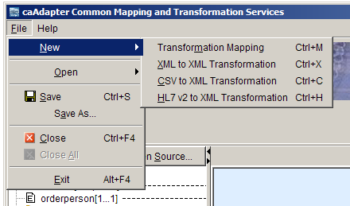

- The system creates a new mapping tab with empty source and target panels.
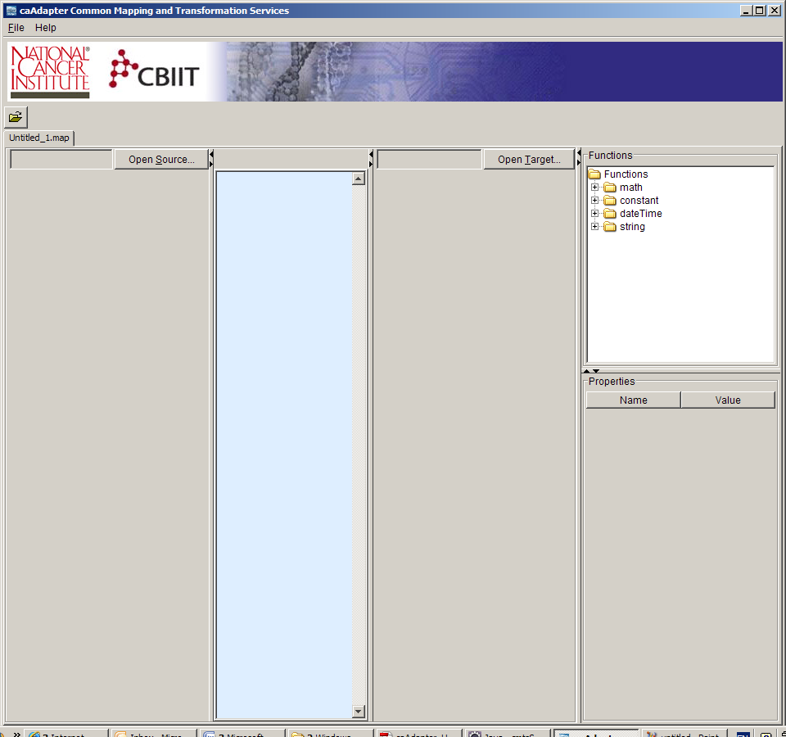

- Click Open Source to display the Open Source File dialog box.
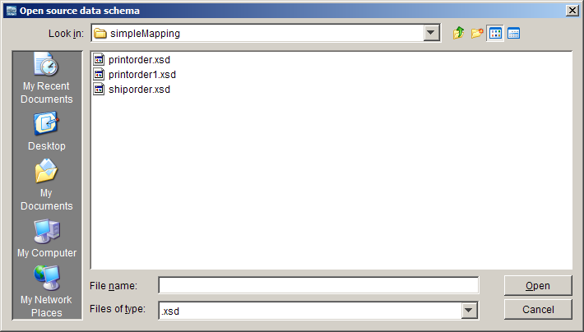
- Select the source file and click Open to populate the source panel with its tree structure.
- Click Open Target to display the Open Target File dialog box.
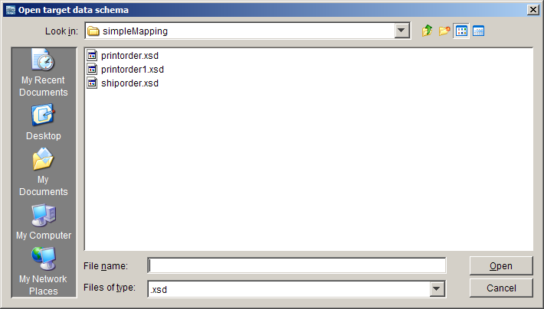

Open existing transformation mapping
To open an existing transformation mapping, perform the following steps:

- Select File > Open > Open
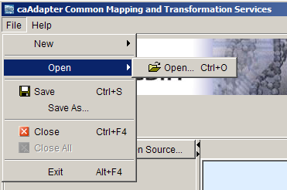

- The Open Map File dialog box appears
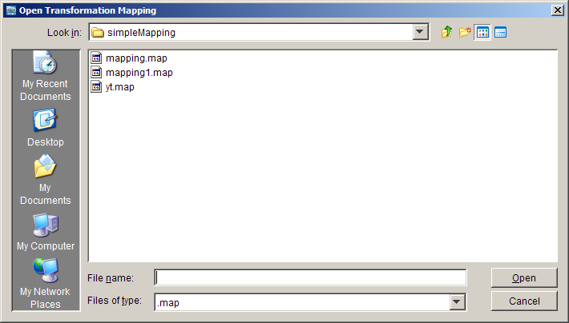

- Select the map specification file and click Open to display the source and target trees along with any existing mappings.

Create Mapping Link
To create a mapping link, perform the following steps:
- Select a source entry and drag it to the appropriate target entry. The cursor indicates if the source is not allowed to be mapped to the target element. The cursor indicates when the source can be mapped to the target element.
- Drop the source on the target element.

- Once a source field is mapped to a target element, a mapping line appears between them in the mapping panel. The following screen shot shows a mapping line between address[1…1] and shipto[1…1].
- 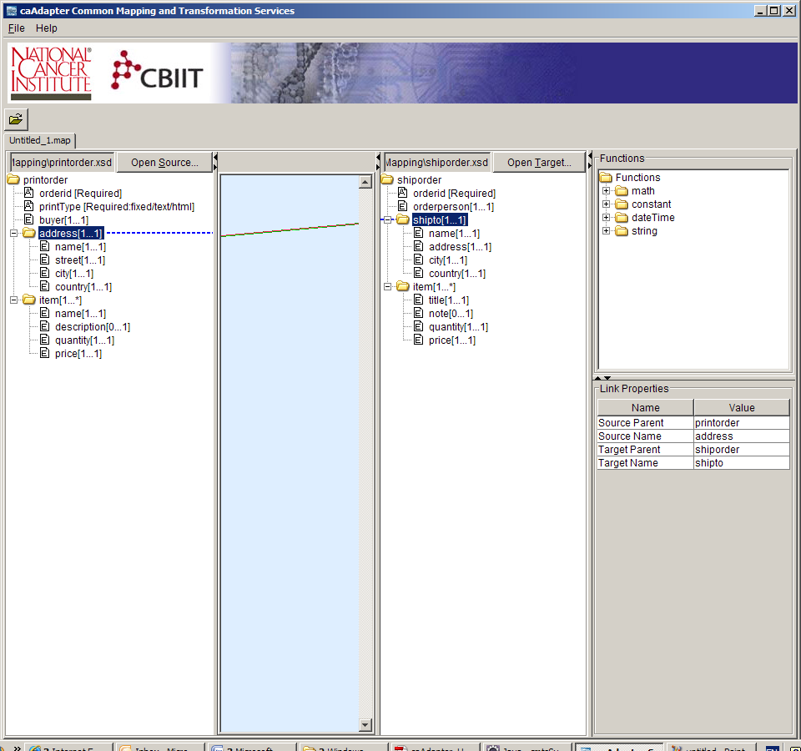

- Tip: To delete a mapped line or a function in the center panel, select the item you want to delete, right‐click it, and select Delete or Delete All. Click Yes to confirm the deletion. The selected item is deleted from the mapping.

- The Properties panel displays information about the selected element.
- Note that when you select a source or target entry, the XML Schema Entry (Attribute/element) Properties appear. When you select a mapping line, the Link Properties appear. When you select a function in the Mapping panel or in the Functions panel, the Function Properties appear.

Delete Mapping Link
To delete a mapping link, perform the following steps:
- Right-click any mapping line to select it. A popup menu appears.
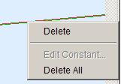
- Click Delete to delete only the selected mapping line.
Alternatively, click Delete All to delete all mapping lines (including those you have not selected). A message appears asking you to confirm the deletion(s). If you select Yes, all mapping lines are deleted.

Save Transformation Mapping
When you finish working on the map specification, select File > Save or File > Save As from the menu bar to save the file. This file is portable and can be opened by the same or another user later.

Caution: The transformation mapping has an internal reference to the full path name of the source and target schema files and those must be accurate to process the conversion or edit a transformation mapping successfully. If you are sharing a transformation mapping files with other users, you must send all three files: source data schema, target data schema and mapping file (.map); not just the mapping file. Furthermore, these files must be in the same path locations as they were on the machine where they were created. Alternatively, the path name can be manually removed by editing the .map file however this is dangerous and unpredictable results may occur if the file is changed improperly.

Use Functions in Transformation Mapping
The Functions panel provides a list of system defined functions that facilitate the data transformation requirement. Functions are grouped by functional categories (for example, constant, date, math, string, etc.). You may use a function in the mapping to effect a change of the source element to the target element. For example, you can use the concatenate function to add a prefix to an element.

Add function in transformation mapping
To add a function item in transformation mapping, perform the following steps:
- Select a function in the Functions panel.
- Drag-and-drop the required function from the Functions panel to the mapping panel
- Move this function box around the mapping panel as convenient to attach the map.
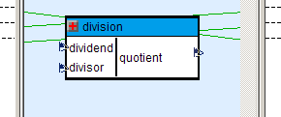
Figure: Add function to transformation mapping.

Create mapping from source schema entry to function input port
To create a mapping link from source schema entry to function input port, perform the following steps:
- Select a schema entry from source schema tree
- Drag-and-drop the selected schema entry to an input port of function box on the mapping panel.

Create mapping from function input port to target schema entry
To create a mapping link from a function output port to a target schema entry, perform the following steps:
- Select a schema entry from target schema tree
- Drag-and-drop the selected schema entry to an output port of function box on the mapping panel.

Delete function from transformation mapping
To delete a function item from transformation mapping, perform the following steps:
- Select a function box in the mapping panel.
- Right click the selected function box, a popup menu appears.
- Click Delete menu item.
- The selected function box is removed from mapping panel.

Edit Constant Function
To edit a constant function, perform the following steps.
- Select a constant function in the mapping panel.
- Right-click and selected function box, a popup menu appears.
- Click Edit Constant menu item. The Edit Constant dialog box appears.
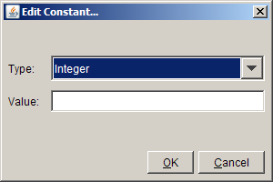

- Change the Type and/or Value for the constant and click OK.

Use Math Function Group
The Math function group includes the following functions:
- abs – Returns the absolute value of the argument
- ceiling -- returns the smallest integer that is greater than the number argument
- floor -- returns the largest integer that is not greater than the number argument
- round -- rounds the number argument to the nearest integer
- addition – return the sum of term1 and term2
- subtraction – return the difference of term2 from term1
- multiplication – return the product of factor1 and factor2
- division – return the quotient of the dividend and divisor
- modulus – return the rounded quotient of the dividend and divisor

Use Date Function Group
The Date function group includes the following functions:
- currentDate – Returns the current date (with timezone)
- currentDateTime -- Returns the current dateTime (with timezone)
- currenttime -- Returns the current time (with timezone)
- countDays -- Returns an integer that represents the day component in the localized value of the argument

Use String Function Group
The String function group includes the following functions:
- length – Returns the length of the specified string.
- lower -- Converts the string argument to lower-case
- upper -- Converts the string argument to upper-case
- concatenate -- Returns the concatenation of the strings
- substringAfter – Returns the remainder of string1 after string2 occurs in it
- substringBefore – Returns the start of string1 before string2 occurs in it
- substring – Returns the substring from the start position to the specified length. Index of the first character is 1.
- replace – Returns a string that is created by replacing the given pattern with the replace argument

Annotate XML Schema

In the conforming process, caAdpater CMTS handle annotate an XML schema with the following kinds of actions:
Choice Element – XML Schema choice element allows only one of the elements contained in the <choice> declaration to be present within the containing element. The annotation process allows user select one and only element to be present.
Clone Element – If the “maxOccurs” is more than one or “unbounded”, it could be mapped to more than one sources/targets. The annotation process allows user to clone the same element for mapping purpose.

Recursive Data Type – If the data type of element is same with its ancestor, it is referred as recursive element. As default, caAdapter CMTS mapping panel only display the name of recursive data type without any content to avoid any indefinite loop. The annotation process allows user to navigate a recursive data type down level by level.

Add Clone Element
To clone an element, perform the following steps:
- Select element. A popup menu appears.
- The Add Clone menu item is enabled if the selected element has “maxOccurs” greater than one or “unbounded”
- Click Add Clone menu item, the selected element would be cloned and added to the schema tree. User can only clone an element from the “original” element, i.e. the cloned element can never be cloned.

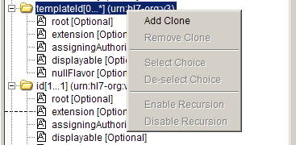

Remove Clone Element
To remove a cloned element, perform the following steps:
- Select element. A popup menu appears.
- The Remove Clone menu item is enabled if the selected element is a cloned element.
- Click Remove Clone menu item, the selected element would be removed from the schema tree.

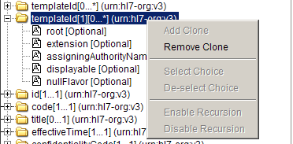

Select Choice Child Element
To select a child for choice element, perform the following steps:
- Select a child element of “<choice>” element. A popup menu appears.
- The Select Choice menu item is enabled if the selected element has not been selected.
- Click Select Choice menu item, the selected child would set as “Selected” child for the choice element and the other “Selected” child would be removed.

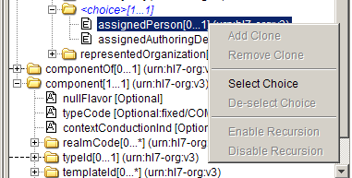

De-select Choice Child Element
To de-select a child for choice element, perform the following steps:
- Select a child element of “<choice>” element. A popup menu appears.
- The De-select Choice menu item is enabled if the selected element has been selected before.
- Click De-select Choice menu item, the selected child would be removed.

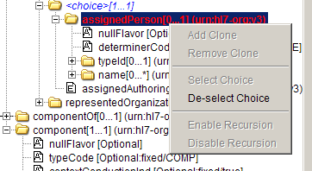

Enable Recursion
To navigate a recursive data type down to next level, perform the following steps:
- Select element with recursive data type. A popup menu appears.
- The Enable Recursion menu item is enabled if the selected element does not have its content displayed.
- Click Enable Recursion menu item, the selected element would navigate down one more level.

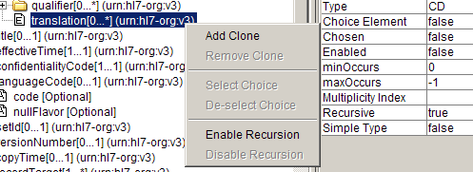

Disable Recursion
To disable a recursive element, perform the following steps:
- Select an enabled recursive element. A popup menu appears.
- The Disable Recursion menu item is enabled if the selected element has its contents displayed.
- Click Disable Recursion menu item, the selected element would remove all its contents.

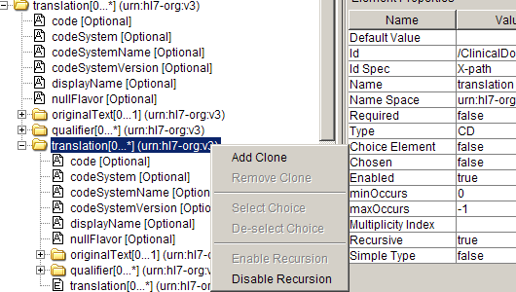

Chapter III Data Transformation
Once a transformation mapping is created between a source data schema and a target data schema. User is able to convert a source into target data using the define transformation mapping.

About the Data Transformation Tab
The purpose of the HL7 v3 Message tab is to allow you to generate and view the XML
instances and messages converted from a data file and map specification. Each data
file may have one or more logical records which result in a corresponding number of
XML instances (or more depending on the structure of the mapping). The user interface

Chapter IV Programming APIs

Chapter V Transformation Webservice

